Yurii Oleksandr Bibik

Dr. Kang

CS 422

15 February 2023

Homework 1

Task 1:   
 In the code, I firstly imported the necessary libraries. Then, I read the MNIST data from a csv file and separated the target variable (the digit labels) and the feature set (the pixel values). I used PCA (Principal Component Analysis) from the scikit-learn library to reduce the dimensionality of the feature set from 784 to 2. Next, I visualized the transformed data using a scatter plot, where each group of 100 data points (representing a single digit) is plotted with a different color. Then I added labels to the x, y axis and the chart itself. I also added a legend to the plot to show which color represents which digit. Finally, I displayed the plot using plt.show().

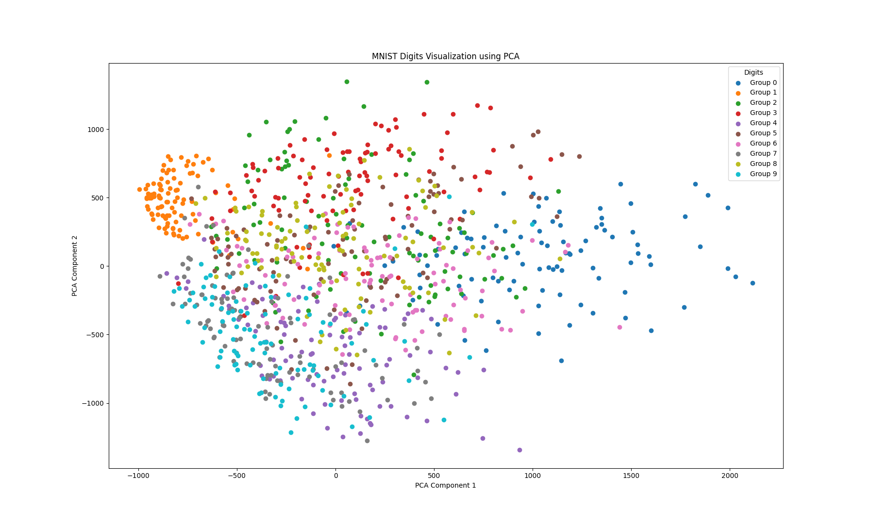

Task 2:

In the code I used the pandas and matplotlib libraries to visualize the columns "K", "M", and "N" from the housing dataset. Firstly, it reads the data from a .csv file. Then I renamed the columns from their numbers to "K", "M", and "N". Then, I created a box plot of the data using the matplotlib library. Then I added labels to the x, y axis and the chart itself. The box plot provides information about the density and distribution of the data values at different values. Finally I displayed the boxplot using the plt.show() command.

Task 3: Visualize the column of A in the housing data using histogram. (30 points)  
 In the code I visualize the distribution of the data in column 0 (referred to as "A") of a housing dataset. Firstly, I import the necessary libraries. Then I read the housing data from a CSV file. Then I create a histogram of the data in column 0 (“A”). I added labels to the x, y axis and the chart itself. Finally, I displayed the plot using plt.show().

